**Assignment #4: My Typing Credentials = Elite**

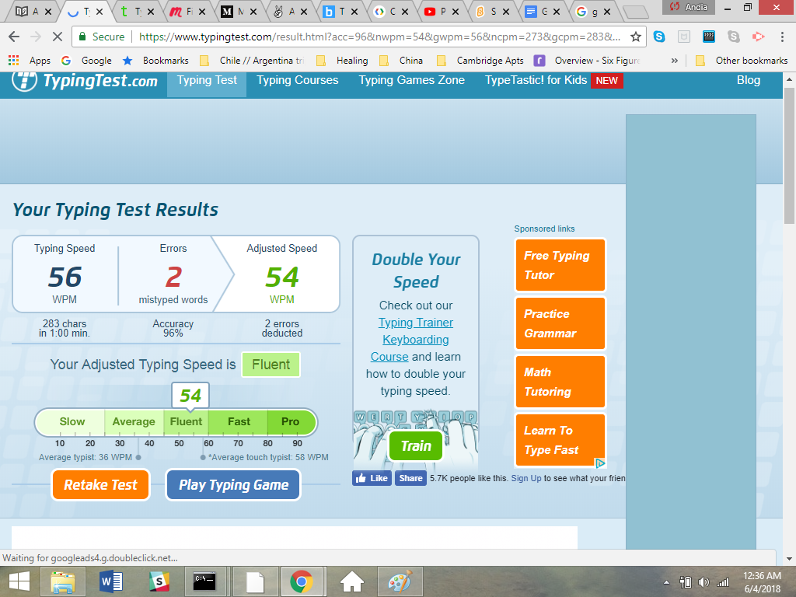

This was the best I could do for coding/minute, I will keep trying ☺

